A000-AFR-EGY-Ushabti-Vizier Kagemni and pig-Old Kingdom-2330 BCE

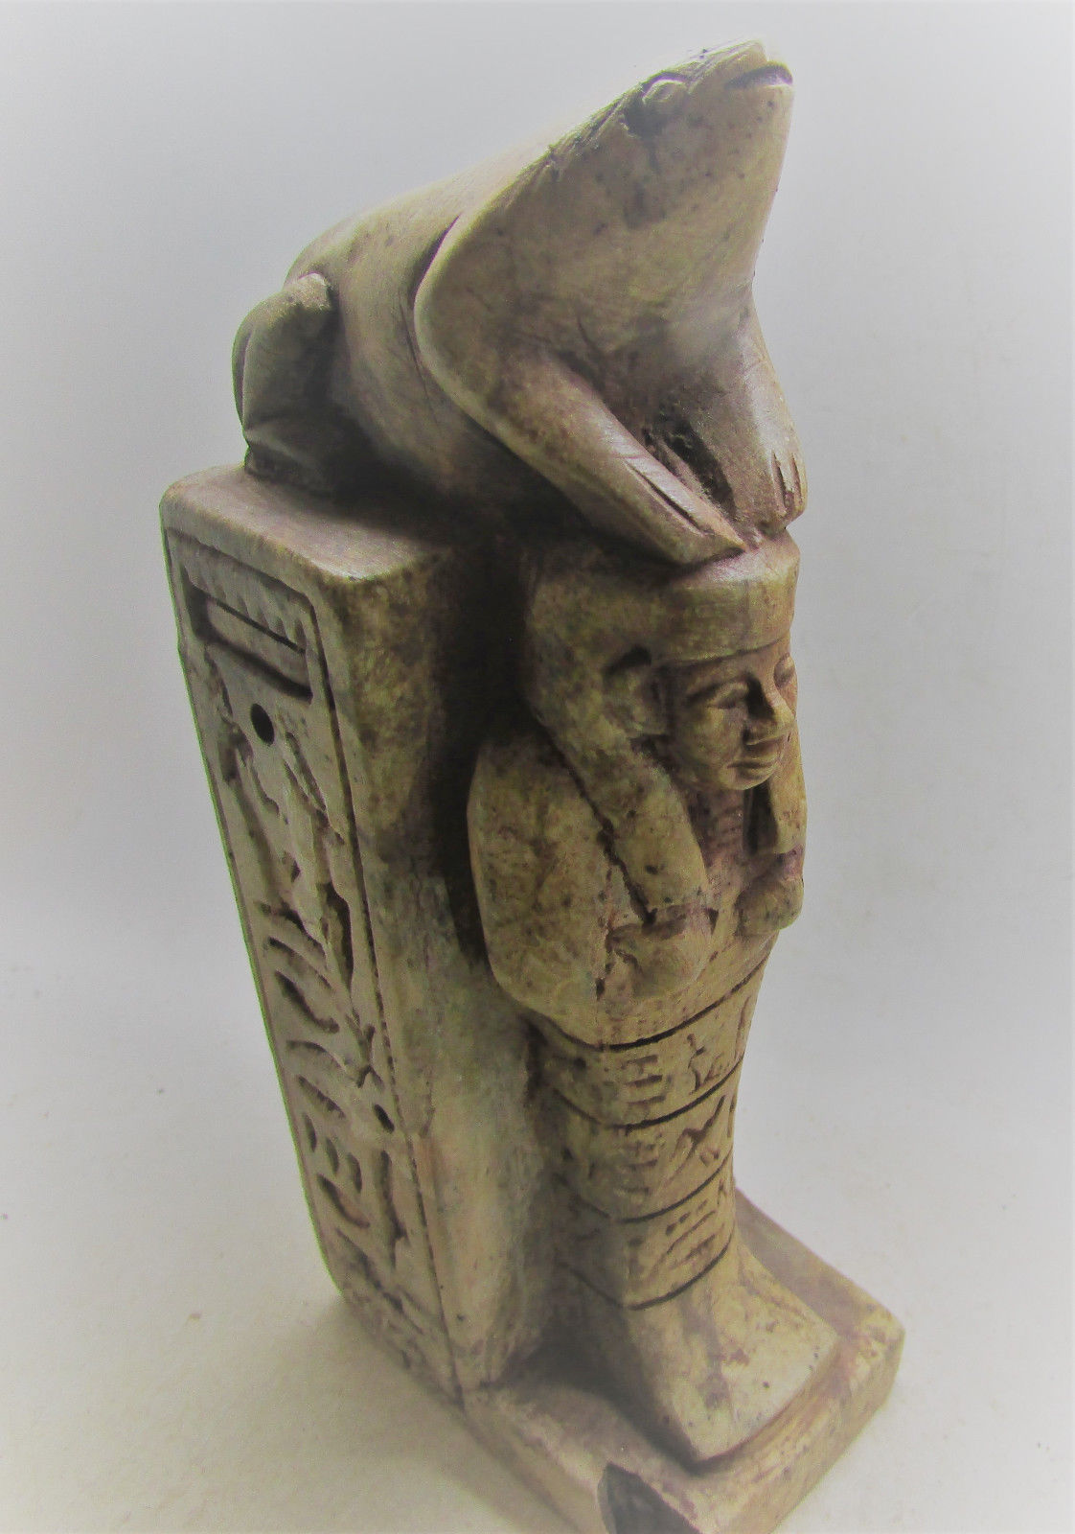 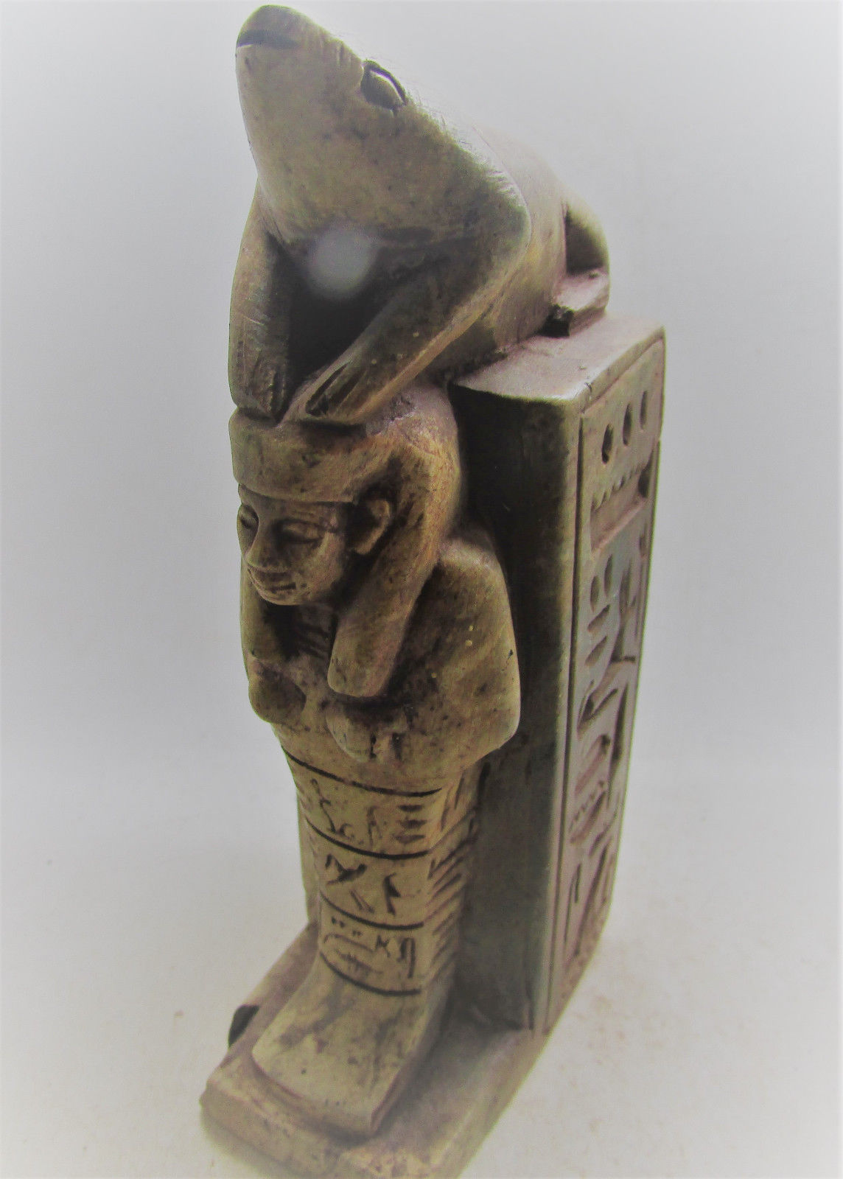 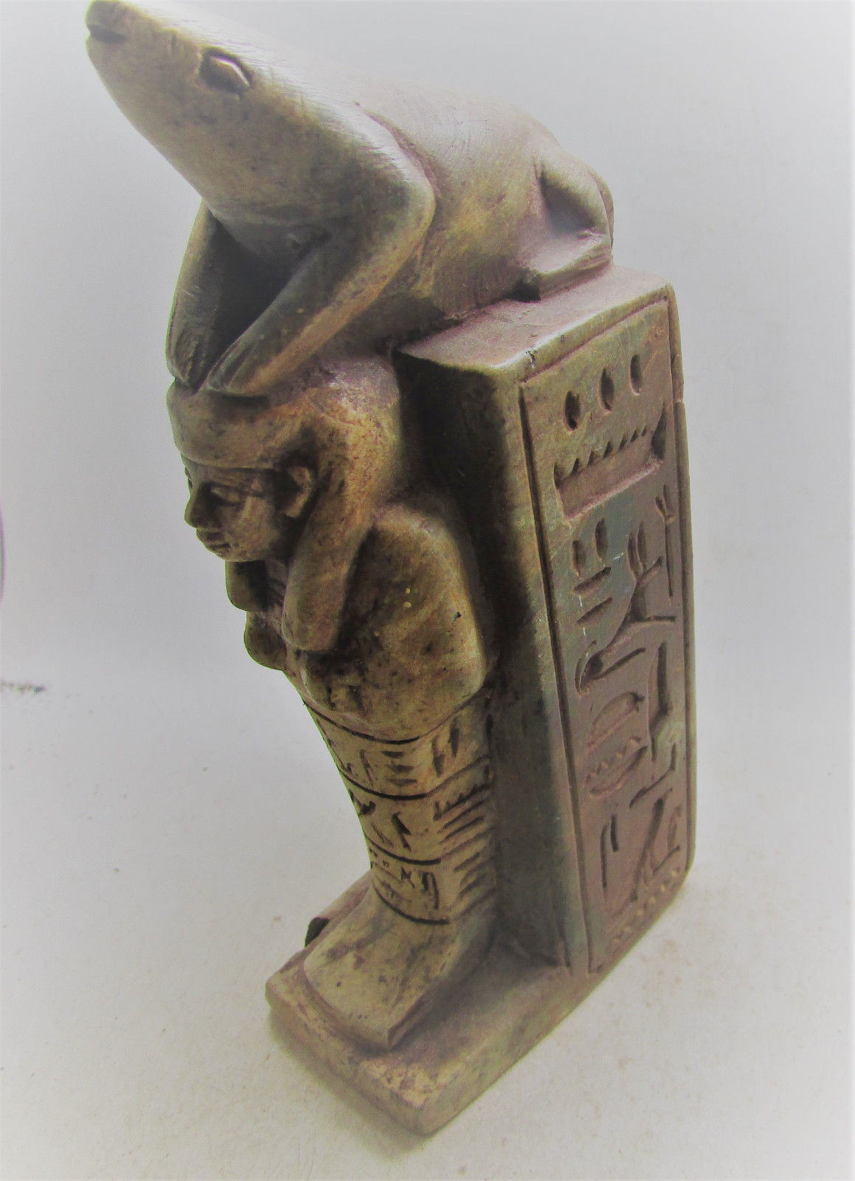

**Case no.: 2**

**Accession Number:**

**Formal Label:**

**Display Description:**

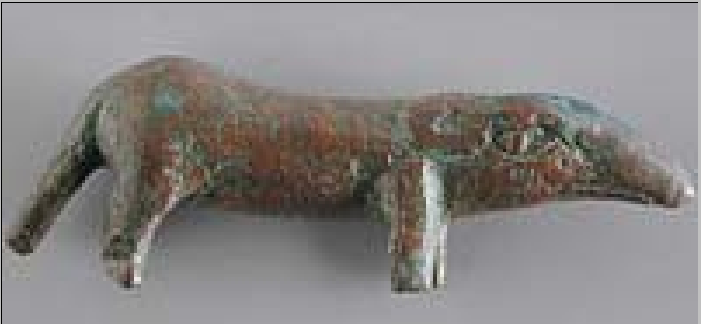

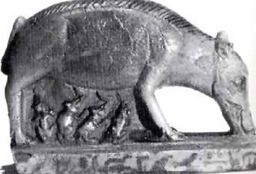

The ancient Egyptians referred to pigs, boars or swine as,

1. /rri/  **"rery"** - boar, piglet  
  
2. /rrt/ **"reret"** - swine  
  
3. /SA/ **"Sha"** - pig  
  
4. /ApH/ **"Apeh"** - pigs, swine  
  
These same pigs/hogs/boars/swine are well documented, verified and identified to have existed in ancient Egypt, as far back as the pre-dynastic periods.

Conducting a general search of animals in ancient Egypt, will produce strong results, the familiarity of the pig in ancient Egypt, prior to Zoser and Imhotep is easy to find. Nuwaupians can't cite a single historical account of this pig creation from any ancient Egyptian source.

**1.** "The Egyptian Museum in Berlin also holds a ceramic statue dated to the Naqada I periodof what has been called a pig deity, indicating at least that swine formed a part of religious life at this time. The Brooklyn Museum also possesses a cylinder seal dated to the First Dynasty that displays figures of bristling pigs carved on it, and other seals from this period also depict pigs."

-<http://www.touregypt.net/featurestories/pigs.htm>

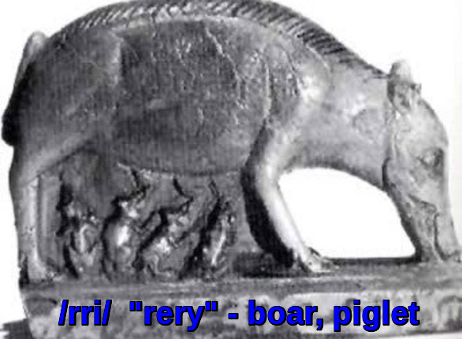

"**4500 BC** is the start of the 'Old' Predynastic, also known as the Amratian period, or simply as **Naqada I**, as most of the sites from this period date to around the same time as the occupation of the Naqada site."

- <http://www.touregypt.net/ebph5.htm>

**2.**"The oldest domestic pig remains presently known in Egypt come from the large predynastic settlement site of Merimda Beni Salama in the western Delta, dated to the fifth millennium BCE."

"Pig remains have been found throughout Egypt at sites such as Hierakonpolis, Maadi, Abydos, and Armant, near graves belonging to the poorer classes, indicating that pork was an element in their diet, at least at the 'Predynastic period'. Cattle bones were found in graves belonging to more elite burials."

- [http://www.touregypt.net/featurestories/pigs.htm](http://www.facebook.com/l.php?u=http%3A%2F%2Fwww.touregypt.net%2Ffeaturestories%2Fpigs.htm&h=-AQGwnlwwAQFiDheKqn6q96qiCq6I7_x_SkfkS5tgub5t0A&s=1)

**3.** The Eleventh Dynasty tomb of the nomarch Khety at Beni Hasan depicts a herd of pigs, the first in Egyptian art since the First Dynasty.

- <http://www.touregypt.net/featurestories/pigs.htm>

**4.** "When Horus was still in his childhood, the animals for sacrifice to the gods consisted of his cattle, his small livestock and his pigs."

- <http://www.reshafim.org.il/ad/egypt/bestiary/pig.htm>

**5.**"...Then Horus looked at that injury. It assumed the form of a black pig. Thereupon Horus shrieked because of the state of his eye, which was stormy [inflamed]. Horus said: "Behold, my eye is as at that first blow which Seth made against my eye!" Thereupon Horus swallowed his heart before him [lost consciousness]. Then Re said: "Put him upon his bed until he has recovered." It was Seth---he has assumed form against him as a black pig..."

- <http://www.fordham.edu/halsall/ancient/1900horuspig.asp>

This excerpt from the Egyptian Coffin Texts mentions the pig in early Egypt. but nothing about Zoser creating it.

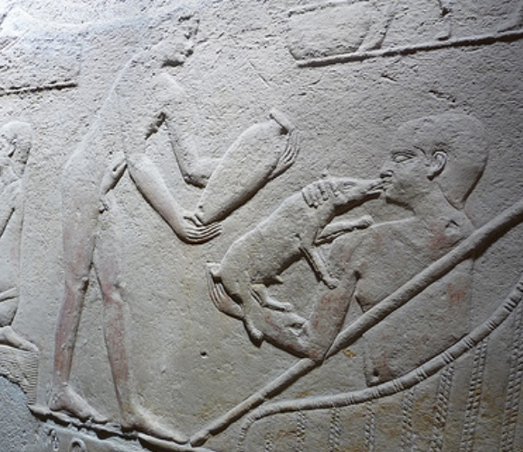

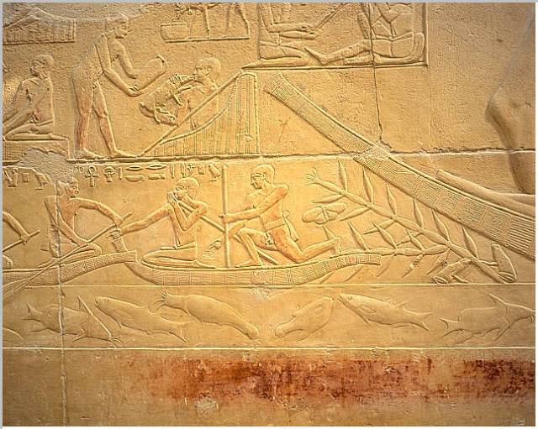

Livestock and fishing activities. Source><http://www.osirisnet.net/mastabas/kagemni/e_kagemni_02.htm>

In the top register of the above relief is shown a swineherd giving what appears to be milk to a piglet.  Another swineherd stands beside him with a vessel containing the milk.  Closeup:

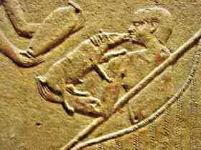

Source: (c) Max Buten

I think that the objective is not to feed an orphaned pig, but to produce fattened suckling pigs for Kagemni’s court.   If so, then the depiction suggests that pork was specially raised and eaten by the elite – at least in the Old Kingdom – and was not an animal eaten primarily by the poor as often suggested for later periods of [Egyptian history](http://en.wikipedia.org/wiki/History_of_Egypt), which was specifically stated by [Herodotus](http://en.wikipedia.org/wiki/Herodotus), who lived over 2000 years later than Kagemni.

‘Even’ food taboos change in the same locale over time.  But the tenancy to think and write about  ancient Egypt as a kind of timeless entity can obscure this reality.

What kind of pig would this have been?  Ancient Egyptian pigs were long snouted and closer to wild pigs, such as this one:

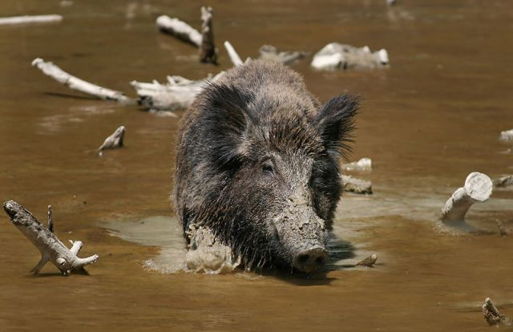

Wild boar in the swamps. Source: Wikipedia

The importance of pigs for Kagemni is suggested in one of his many titles, ‘Overseer of the King’s Fowling Marsh‘.  As shown above, pigs thrive in marshy areas, and from the scenes shown in the registers of his tomb, marshes and aquatic activities were important in Kagemni’s  economic and social activities.

**LC Classification:**

**Date or Time Horizon:**

**Geographical Area:**

**Map:**

**GPS coordinates:**

**Cultural Affiliation:**

**Media:** **Dimensions:**

**Weight:**

**Condition:**

**Provenance:**

MD ANTIQUITIES

Michael Davies

2 hanover court

Didcot

Oxfordshire

ox11 8nu

United Kingdom

**Discussion:**

The topic of [pigs](http://en.wikipedia.org/wiki/Pig) in [Ancient Egypt](http://en.wikipedia.org/wiki/Ancient_Egypt) has had a history based, in early years, perhaps more on pigs in [Egypt](http://en.wikipedia.org/wiki/Egypt) today rather than the raising of pigs based on textual and pictorial records from the [Nile Valley](http://en.wikipedia.org/wiki/Nile).

More pig remains have been recently found at [Amarna](http://en.wikipedia.org/wiki/Amarna), the residence of the Pharaoh Akhenaton, suggesting that pigs may have been ritually/symbolically injured and/or killed – in addition to being eaten.

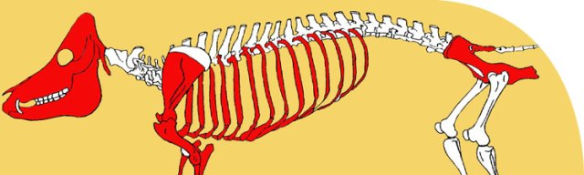

Pig remains at Amarna. Source> The Amarna Project

An intriguing footnote to the history of pigs in Ancient Egypt is found in the tomb of the Vizier Kagemni Kagemni - sm who lived c.2330 BC during the [Old Kingdom](http://en.wikipedia.org/wiki/Old_Kingdom).  In his tomb *mastaba* are wonderfully detailed scenes in raised relief ,  of daily life and of wild life.

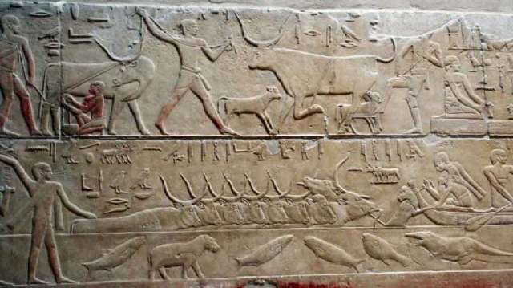

In the lower register, herders move cattle across the water, the herder in front holds a calf that is calling to its mother, thus hurrying the herd forward. Source><http://www.osirisnet.net/mastabas/kagemni/e_kagemni_02.htm>

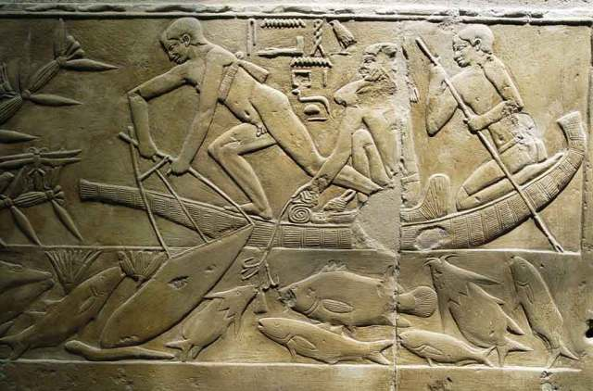

Fishing by means of spears and hooks - over 10 varieties of fish are shown in the full register. Sourcehttp://www.osirisnet.net/mastabas/kagemni/e_kagemni_02.htm

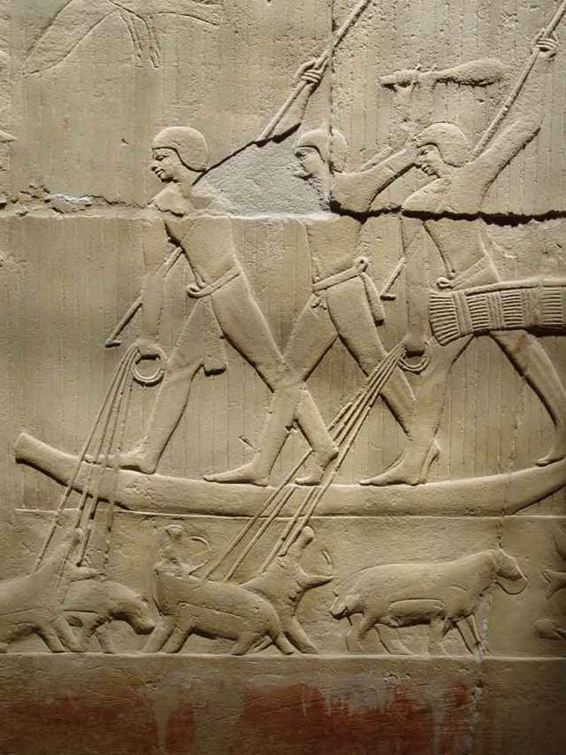

Hunting hippos with spears and ropes - a dangerous occupation; hippos kill more people in Africa than any other animal. They are mean and fast. Source <http://www.osirisnet.net/mastabas/kagemni/e_kagemni_02.htm>



Livestock and fishing activities. Source><http://www.osirisnet.net/mastabas/kagemni/e_kagemni_02.htm>

In the top register of the above relief is shown a swineherd giving what appears to be milk to a piglet.  Another swineherd stands beside him with a vessel containing the milk.  Closeup:



Source: (c) Max Buten

I think that the objective is not to feed an orphaned pig, but to produce fattened suckling pigs for Kagemni’s court.   If so, then the depiction suggests that pork was specially raised and eaten by the elite – at least in the Old Kingdom – and was not an animal eaten primarily by the poor as often suggested for later periods of [Egyptian history](http://en.wikipedia.org/wiki/History_of_Egypt), which was specifically stated by [Herodotus](http://en.wikipedia.org/wiki/Herodotus), who lived over 2000 years later than Kagemni.

‘Even’ food taboos change in the same locale over time.  But the tenancy to think and write about  ancient Egypt as a kind of timeless entity can obscure this reality.

What kind of pig would this have been?  Ancient Egyptian pigs were long snouted and closer to wild pigs, such as this one:



Wild boar in the swamps. Source: Wikipedia

The importance of pigs for Kagemni is suggested in one of his many titles, ‘*Overseer of the King’s Fowling Marsh*‘.  As shown above, pigs thrive in marshy areas, and from the scenes shown in the registers of his tomb, marshes and aquatic activities were important in Kagemni’s  economic and social activities.  It is possible that suckling pigs were roasted as in [Bali](http://en.wikipedia.org/wiki/Bali), where they feature as a major culinary treat being spit-roasted:

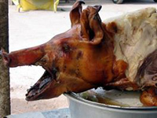

Spit-roasted suckling pig in Bali. Source: baliblog.com

And as we will see in an upcoming blog,, at least in later periods of Egyptian history, different parts of the pig were used in medical treatment, in spite of their mixed reputation.  All of which suggests, at least to me, that throughout over 3000 years of history there are simply too many lacunae along the historical trail to allow for many generalizations.  A bit of data here; a bit there, serendipitously preserved, is what remains.  Kagemni apparently raised suckling pigs for the table – but royalty during the time of Herodotus wouldn’t be seen dead with such a depiction in their tomb… At least not according to Herodotus.

**The Noble Kagemni:**

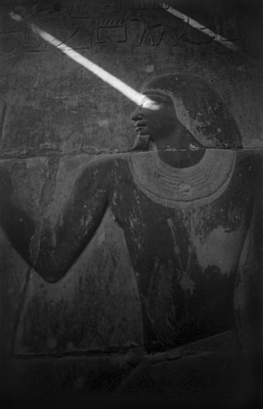

Kagemni, Tomb at Saqqara. Source: (c) Greg Reeder

*“The State Vizier, Kagemni, says: ‘I was the favourite of (the pharaoh)…  I filled the task of civil servant of the state, in the time of (the pharaoh) Unas.  His Majesty rewarded me very generously… (he) named me as the head of all offices, on service at any hour at the Residence.  His Majesty had confidence regarding all things which (he) had ordered to be done, because I was capable… You won’t be able to throw slanders against me, because the sovereign knows my character and my conduct…pleased that in his civil servant…speaks the truth and repeats the good in what the king likes.’”*

*– Inscription from the tomb.  Source:  Osirisnet*

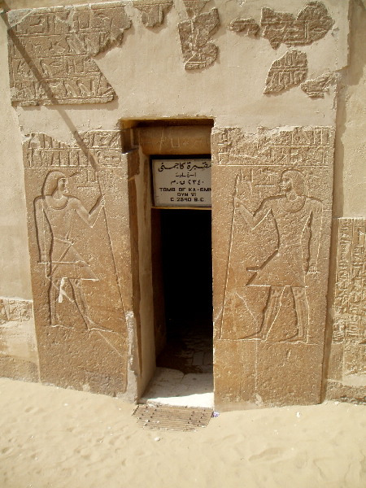

Mastaba (tomb) of Kagemni under Pharaoh Teti I of the VI Dynasty

I want to end with a few words about the Vizier Kagemni, in whose tomb all of this information is found, for he was a fascinating nobleman.  He married the Pharaoh’s daughter and aside from being Vizier, held over 100 other titles, amongst which were several that are interesting for their agricultural activities:

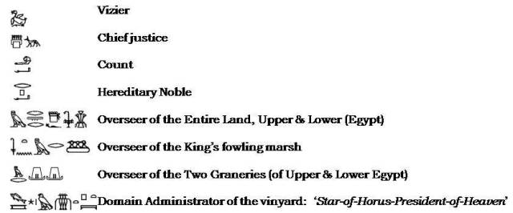

. Source: Osirusnet

Above are listed several of Kagemni’s titles that I’ve selected, showing the importance of various agricultural activities.  He controlled not only fowling grounds, but also the granaries of Upper and Lower Egypt as well as what must have been a major vineyard

As for the *Instructions* by which future generations remembered him, only a few lines are left.  They are sections that deal primarily with food and eating:

When you sit with company, shun the food you like. Restraint of heart is (only) a brief moment! Gluttony is base and one points the finger at it. A cup of water quenches thirst, a mouthful of herbs strengthens the heart. A single good thing stands for goodness as a whole, a little something stands for much. Vile is he whose belly is voracious; time passes and he forgets in whose house the belly strides. When you sit with a glutton, eat when his appetite has passed. When you drink with a drunkard, partake when his heart is happy. Do not grab (your) meat by the side of a glutton, (but) take when he gives you, do not refuse it, then it will soothe.

He who is blameless in matters of food, no word can prevail against him. The shy of face, even impassive of heart, the harsh is kinder to him than to his (own) mother, all people are his servants. Let your name go forth, while you are silent with your mouth. When you are summoned, be not great of heart because of your strength among those your age, lest you be opposed. One knows not what may happen, and what god does when he punishes.

The vizier had his children summoned, after he had gained a complete knowledge of the ways of men, their character having come upon him. In the end he said to them: “All that is written in this book, heed it as I said it. Do not go beyond what has been set down.” Then they placed themselves on their bellies. They recited it aloud as it was written. It was good in their hearts beyond anything in this entire land. They stood and sat accordingly.

Then the majesty of king Huni of Upper and Lower Egypt died. The majesty of king Snefru of Upper and Lower Egypt was raised up as beneficent king in this entire land. Kagemni was (then) made overseer of the city and vizier. It is finished.”

**References:**